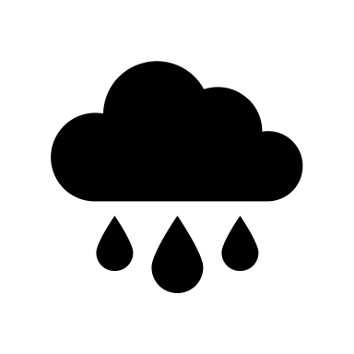

**Weekend Weather Finder**

**Language:** Python (also possible in R, see note)

**Difficulty:** Intermediate?

**Requirements:**

* Python installed and your choice of Python IDE and pip to install Python libraries
* OR Juypter notebook/lab

**Aims:**

* Practice using a simple API in Python to gather data
* Parsing JSON format data
* Data wrangling/manipulation
* Using Python dictionaries
* Writing functions

**Task:**   
You have a free weekend – no work, no kids, and you can visit anywhere in the UK. But where will you get the best weather? Using [Open-Meteo’s free forecast API](https://open-meteo.com/), write a program in Python which will tell you which city in the UK has the best weather for the coming weekend. How you define the ‘best weather’ is up to you!

**Resources:**

* [Open-Meteo’s free forecast API](https://open-meteo.com/) gives access to free forecast data from a range of weather models.
  + To get started, read the docs to see how to use it: <https://open-meteo.com/en/docs> (the section API response has a Python tab which gives example code on how to call the API client).
  + Open-Meteo API Python Client: <https://pypi.org/project/openmeteo-requests/>
* List of UK cities with longitude and latitude: <https://simplemaps.com/data/gb-cities> (can be downloaded as CSV, JSON or Excel format)

**Getting started and help:**

* To begin, query the API to access the daily weather forecast data for a single location and a single date. To extend this to multiple cities and dates:
  + Consider using a dictionary to store the lat and lon information for each city
  + Use the sample code builder on this [webpage](https://open-meteo.com/en/docs) to learn how to input multiple locations (location list option)
  + Consider using a for loop to access the weather data for multiple locations
* If you’re stuck, this blog post can provide help: <https://www.geodose.com/2023/08/get-plot-weather-data-python.html> (note, the blog post uses the library ‘requests’ not ‘openmeteo-requests’, but you can adapt the code to use it if you prefer)

**Extensions:**

* Write a function which returns the top 5 cities for the coming weekend.
  + Modify the function so that the user can choose which weather parameter to base the selection from – e.g. warmest, least chance of rain, least windy.
  + Modify the function so users can exclude cities from the selection. Or only include cities within a certain radius of a given lat/lon (see <https://www.section.io/engineering-education/using-geopy-to-calculate-the-distance-between-two-points/> for help).
  + Add some error handling – what if the user inputs something incorrectly or asks an impossible request (e.g. weather for a date a year into the future) – see <https://realpython.com/python-exceptions/> for help on error handling in Python.
* Add some data visualisations so that the user can make an informed decision about where to visit.
* Turn this project into a program which is executable from the command line/terminal (to get started: <https://realpython.com/run-python-scripts/>)

**R users: this challenge can also be done in R – look into the R package openmeteo:** <https://cran.r-project.org/web/packages/openmeteo/openmeteo.pdf>